**Spike:** 4

**Title:** Emergent group behaviour

**Author:** Ryan Chessum - 102564760

**Goals / deliverables:**

Create a group agent steering behaviour simulation that is able to demonstrate distinct modes of emergent group behaviour. In particular, the simulation must:

•Include cohesion, separation and alignment steering behaviours

•Include basicwandering behaviours

•Use a weighted-sum to combine all steering behaviours

•Support the adjustment of parameters for each steering force while running

**Technologies, Tools, and Resources used:**

* Visual Studio Code
* Python 3.8.0
* Pyglet
* Lecture Notes
* Lab 8 and 9 example code

**Tasks undertaken:**

* Create an agent object with wandering behaviour
* Add global Cohesion, Separation and Alignment variables
* Add global radius variable
* Add a function that can tag neighbouring agents
* Add a function to agent that calculates Cohesion force based on neighbours
* Add a function to agent that calculates Separation force based on neighbours
* Add a function to agent that calculates Alignment force based on neighbours
* Change the Calculate() function so that the directional force of the agent is the weighted sum of all of the forces (wandering force, cohesion force, separation force and alignment force)
* Add game controls that can change the modifiers of each force

**What we found out:**

This method was an interesting way of creating group behaviours.

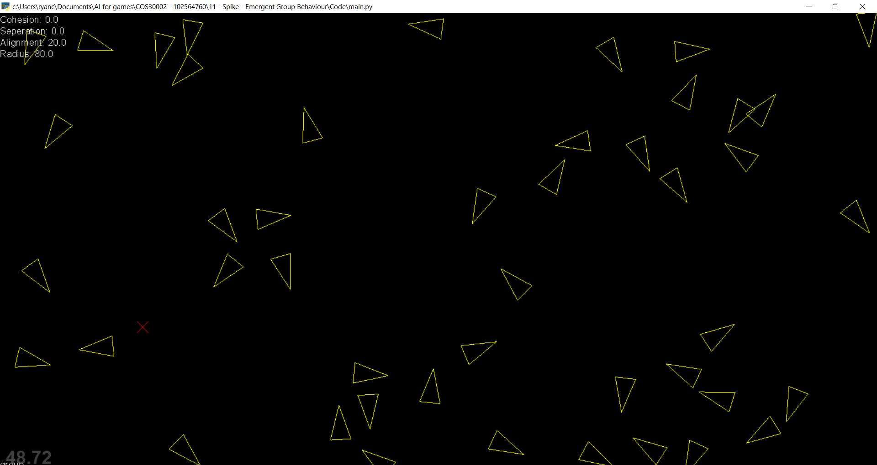

Alignment makes the agents face the same way. As you can see in the picture many of the agents appear to be making a line or are moving in the same direction.

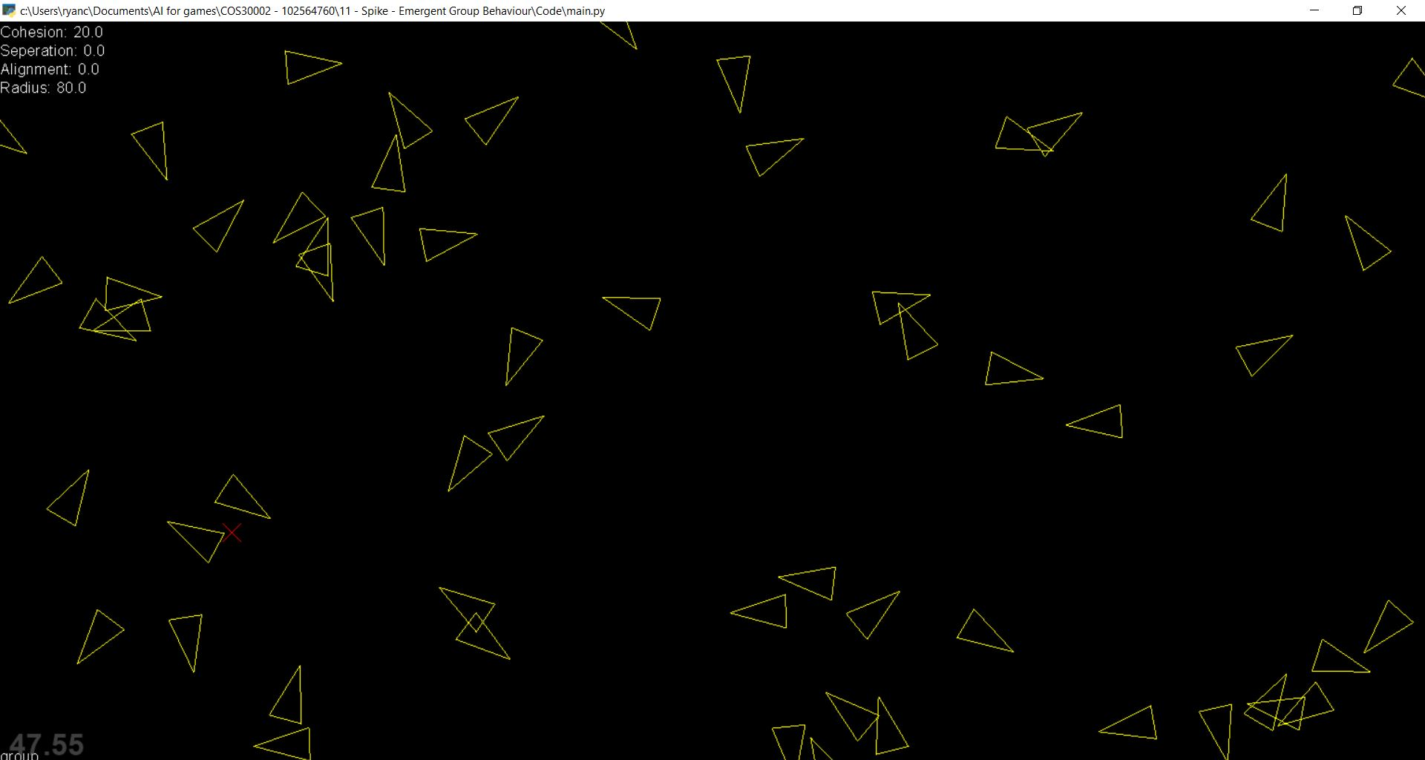

Cohesion makes the agents stay closer to other agents. As you can see in the image the agents are forming giant clumps in different areas on the screen

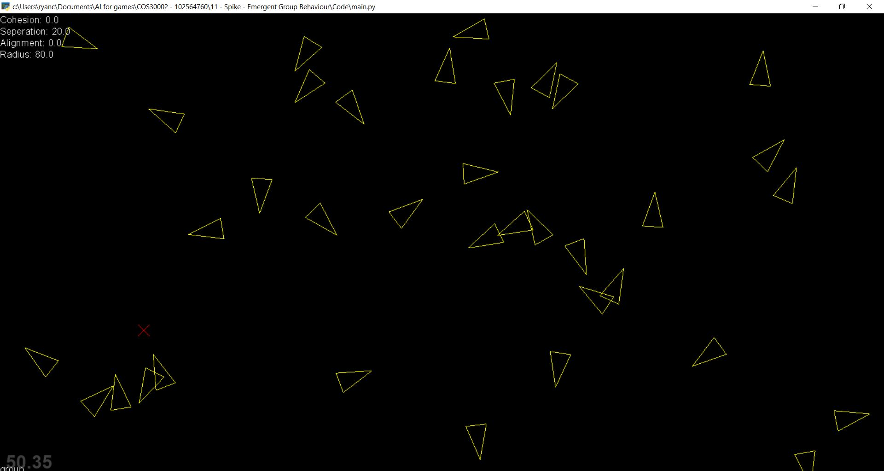

Separation keeps the agents separated by a certain amount. If the agent gets close enough to another agent they move away. See how the overlapping agents are pointing in different directions.

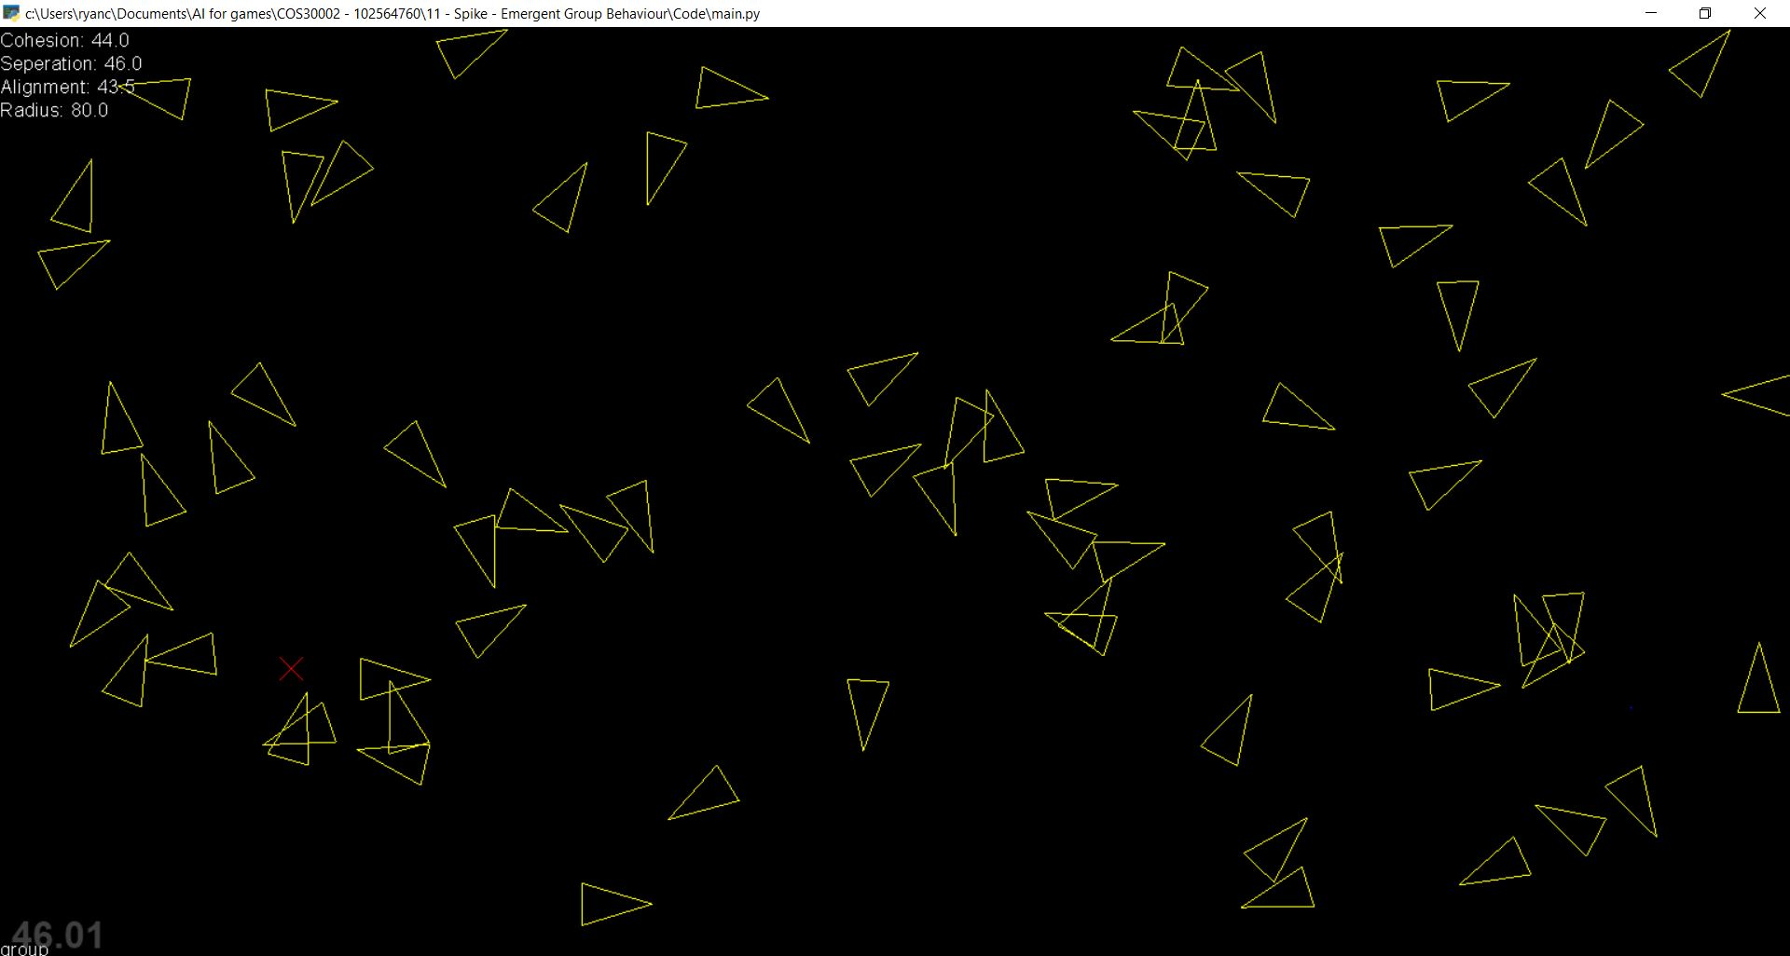

By playing around with these values you can produce many interesting and varied group behaviours.

Keys:

* Create new agent: a
* Increase Separation: h
* Decrease Separation: b
* Increase Alignment: j
* Decrease Alignment: n
* Increase Cohesion: k
* Decrease Cohesion: m